**CP Club 365 Days Challenge**

**Programming language – PYTHON**

**Problem Statement**

<https://www.hackerrank.com/challenges/one-month-preparation-kit-the-birthday-bar/problem?isFullScreen=true&h_l=interview&playlist_slugs%5B%5D=preparation-kits&playlist_slugs%5B%5D=one-month-preparation-kit&playlist_slugs%5B%5D=one-month-week-one>

Git :- <https://github.com/Vedantbharad2603/CP_club_365_Days>

**Your Code**:

# 0x115Day of 0x365Days challenge

# VEDANT BHARAD

# 9-2-2023

import math

import os

import random

import re

import sys

def birthday(s, d, m):

    # Write your code here

    temp1=0

    temp2=m

    con=0

    while temp2<=len(s):

        if sum(s[temp1:temp2])==d:

            con+=1

        temp1+=1

        temp2+=1

    return con

if __name__ == '__main__':

    fptr = open(os.environ['OUTPUT_PATH'], 'w')

    n = int(input().strip())

    s = list(map(int, input().rstrip().split()))

    first_multiple_input = input().rstrip().split()

    d = int(first_multiple_input[0])

    m = int(first_multiple_input[1])

    result = birthday(s, d, m)

    fptr.write(str(result) + '\n')

    fptr.close()

**Output (Screen Shot)**:

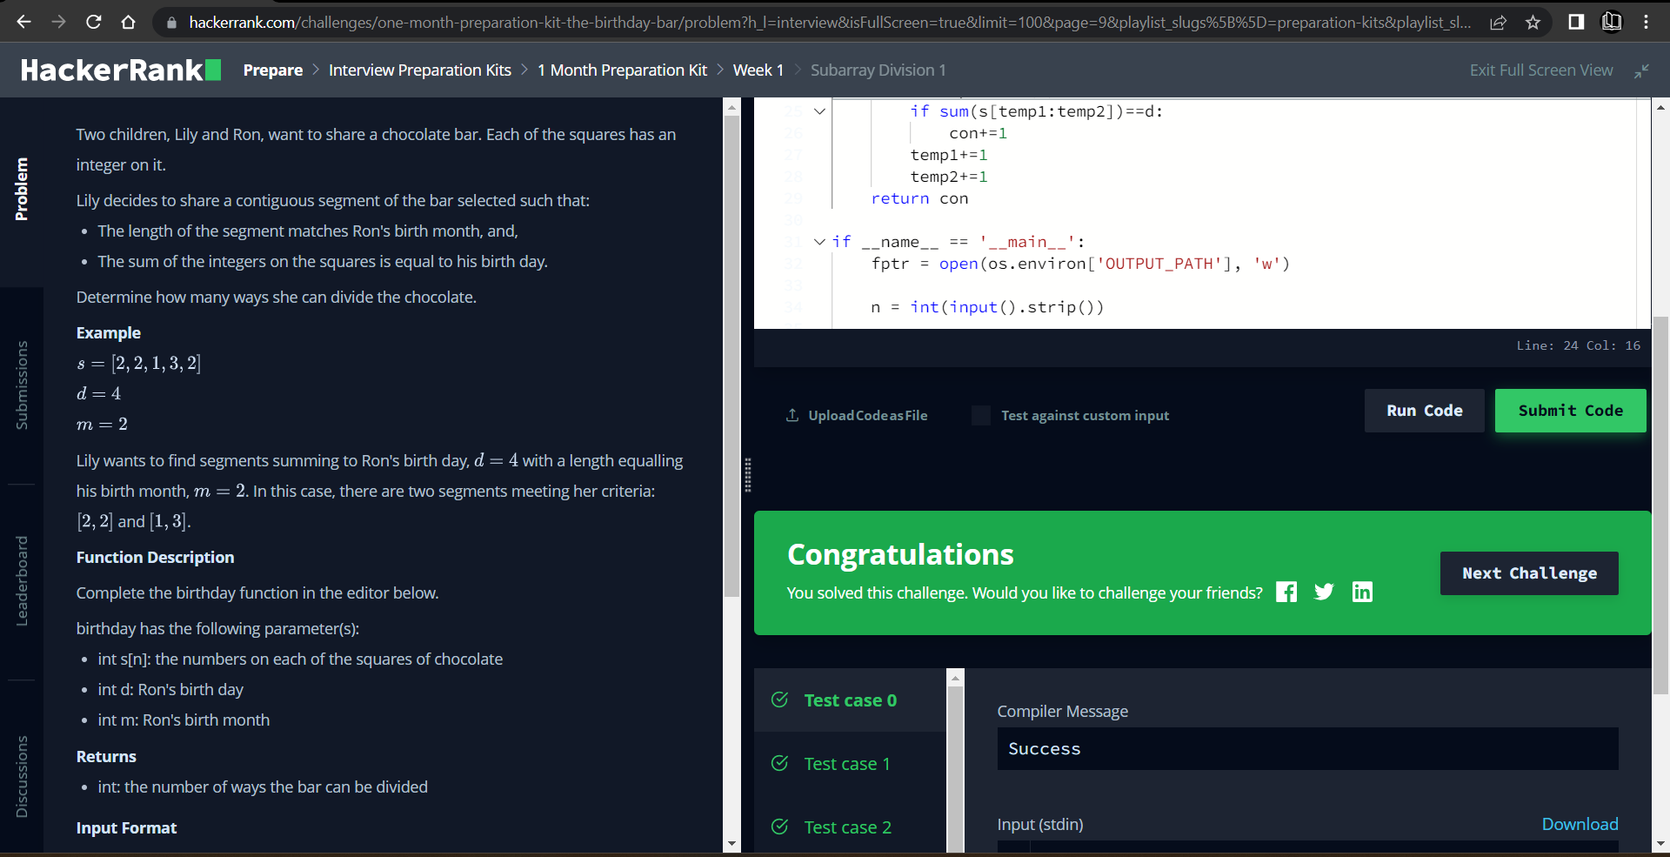

**Understanding about problem:**

* In this task I need to find number which is number of ways to divide the given array.

Note: If you can't understand the problem, feel free to contact us and we'll help you. Please don't copy and paste from anywhere.

ALL THE BEST

Team CP Club